**Assignment 4.2**

1. **WAP to create simple calculator using class.**

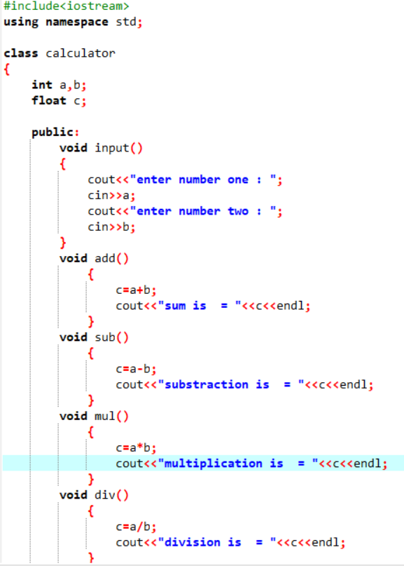

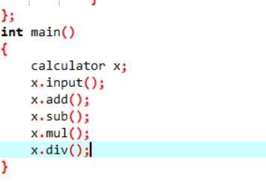

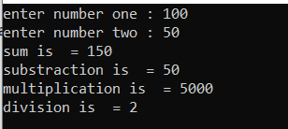

**2)** **Define a class to represent a bank account. Include the following members:**

**1. Data Member: -Name of the depositor -Account Number -Type of Account -Balance amount in the account**

**2. Member Functions -To assign values -To deposited an amount -To withdraw an amount after checking balance -To display name and balance**

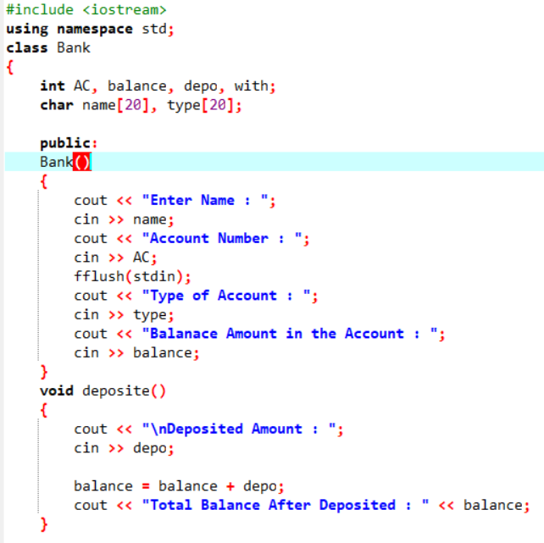

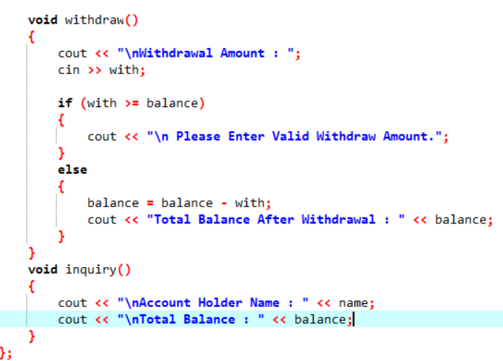

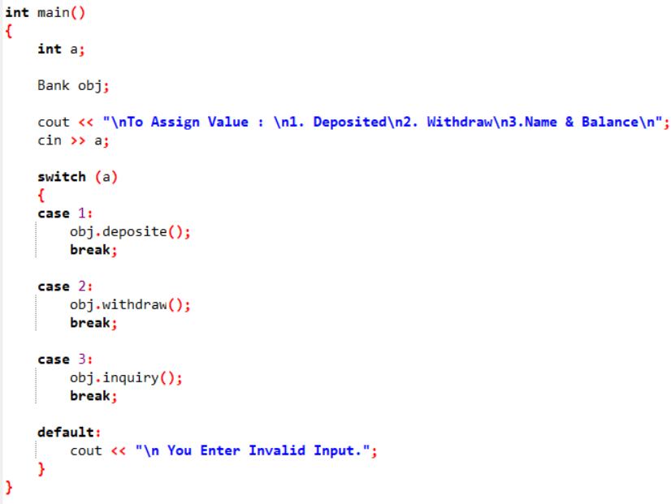

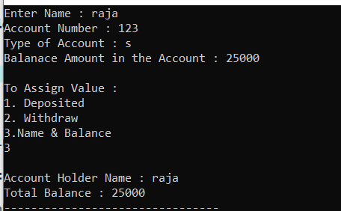

**3 Write a program to find the multiplication values and the cubic values using inline function.**

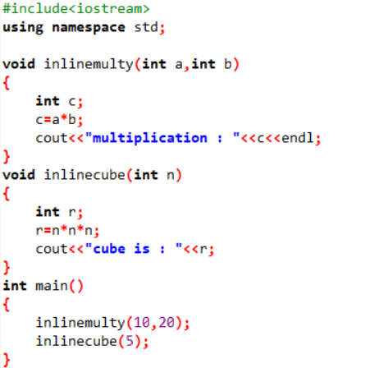



**4 Write a program of Addition, Subtraction, Division, Multiplication using constructor.**

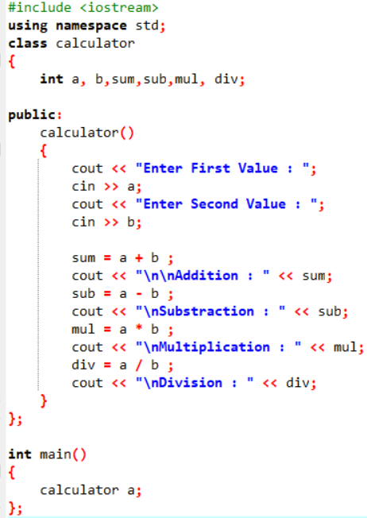

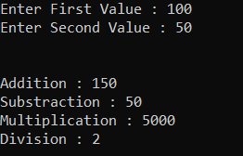

**5 Assume a class cricketer is declared. Declare a derived class batsman from cricketer. Data member of batsman. Total runs, Average runs and best performance. Member functions input data, calculate average runs, Display data. (Single Inheritance)**

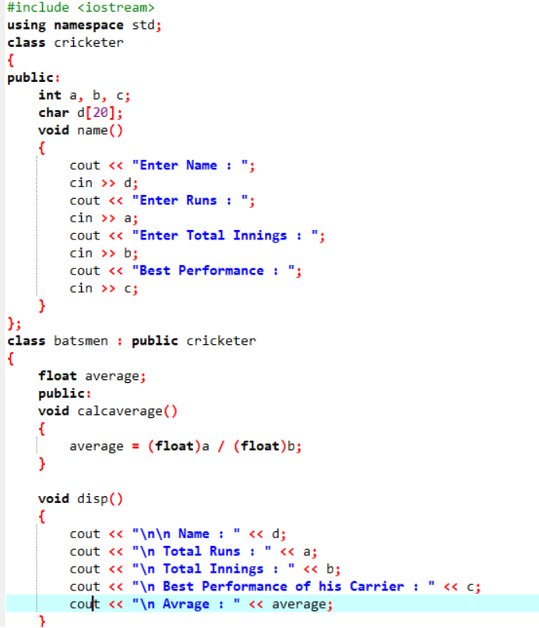

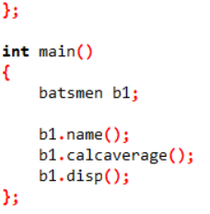 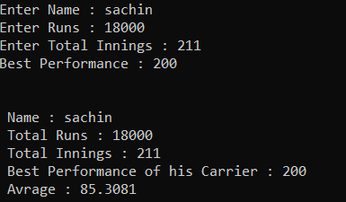

**6 Create a class person having members name and age. Derive a class student having member percentage. Derive another class teacher having member salary. Write necessary member function to initialize, read and write data. Write also Main function (Multiple Inheritance)**

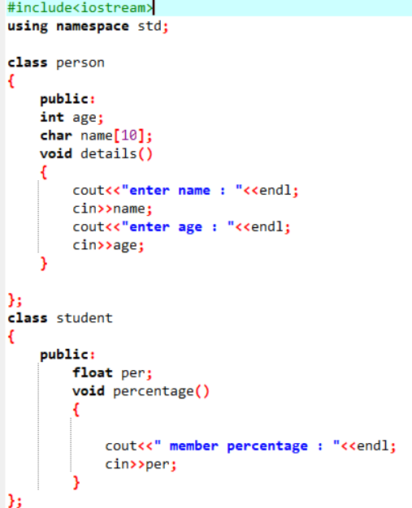

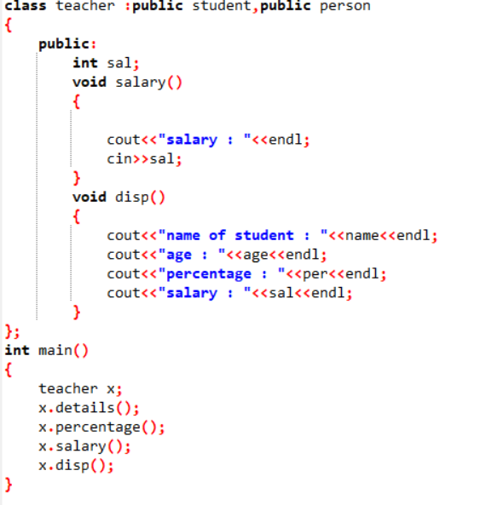

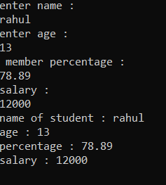

**7 Assume that the test results of a batch of students are stored in three different classes. Class Students are storing the roll number. Class Test stores the marks obtained in two subjects and class result contains the total marks obtained in the test. The class result can inherit the details of the marks obtained in the test and roll number of students. (Multilevel Inheritance)**

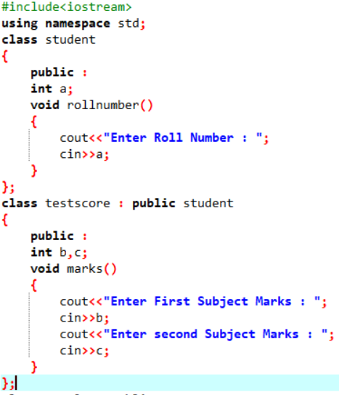

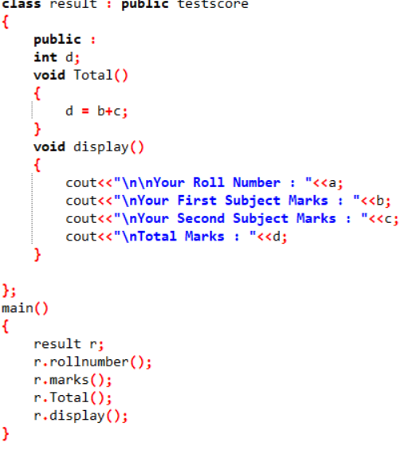

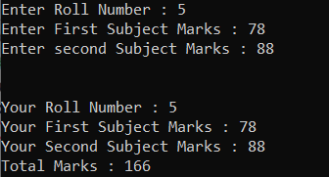

**8 Write a program to Mathematic operation like Addition, Subtraction, Multiplication, Division Of two number using different parameters and Function Overloading**

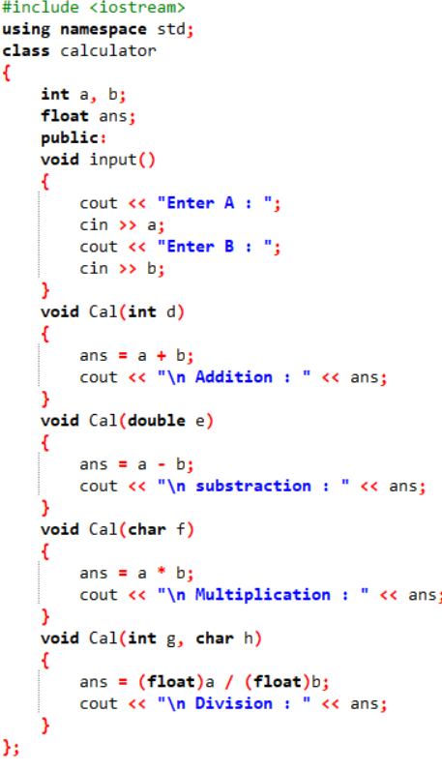

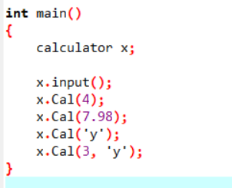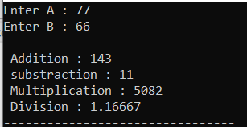

**9 Write a program to concatenate the two strings using Operator Overloading**

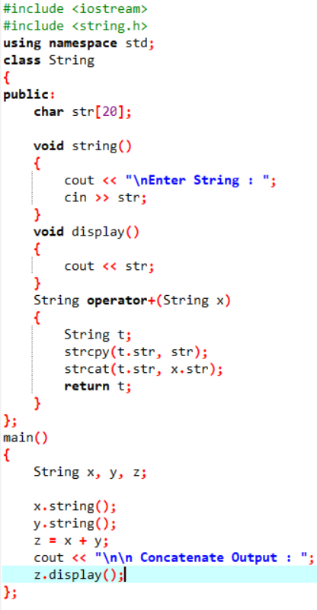

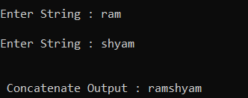

**10 Write a program to calculate the area of circle, rectangle and triangle using Function Overloading Rectangle: Area * breadth Triangle: ½ *Area* breadth Circle: Pi * Area *Area**

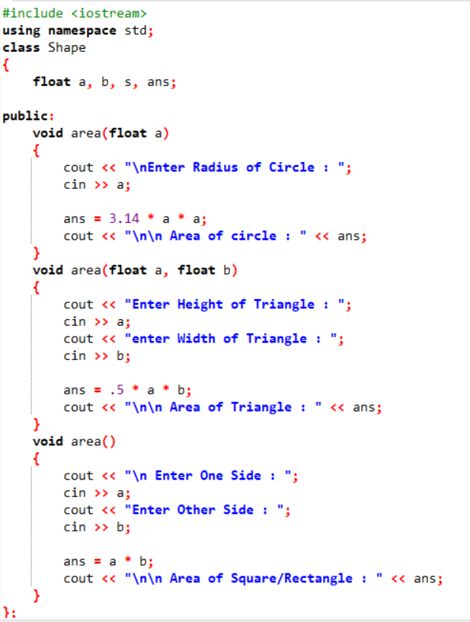

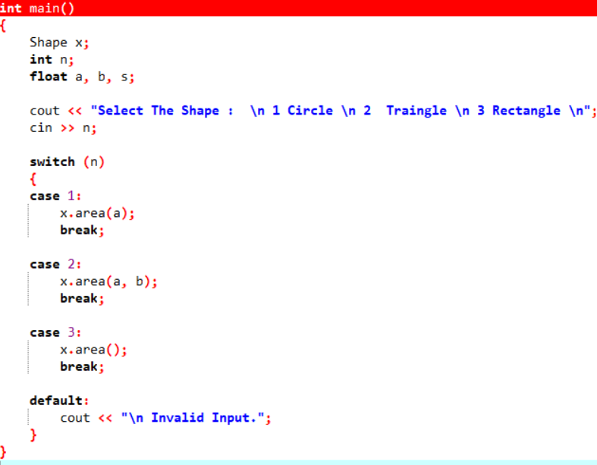

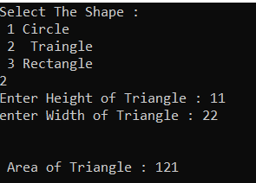

**10 Write a program to swap the two numbers using friend function without using third variable**

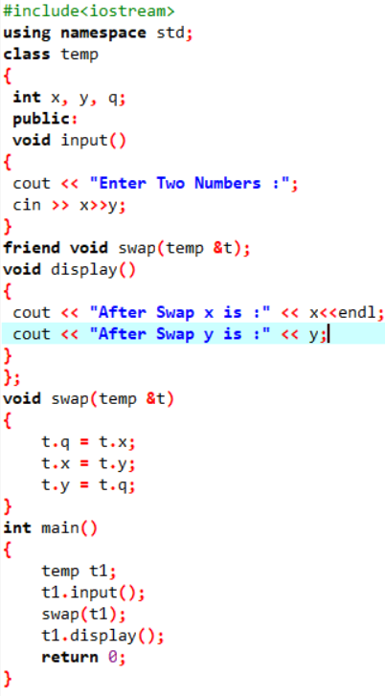

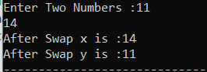

**11 Write a program to find the max number from given two numbers using friend function.**

